2025
Chief C. Kevin King
Fire District 13 Inc
03/12/2026
FD13 Annual Report
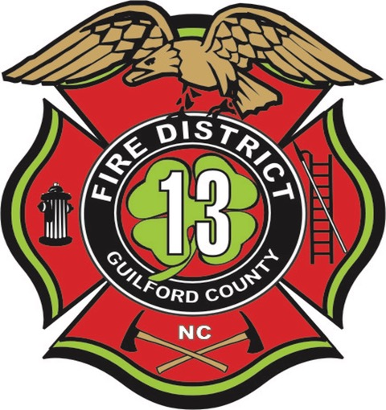

Executive Summary
FD13 provides comprehensive fire protection and emergency services to the Rankin Fire District and surrounding areas in northeast Greensboro, North Carolina. The department continues to maintain a strong balance between operational readiness, personnel wellness, and community safety.
Key highlights from the past year include:
- Emergency Response and Training accounted for 87.48% of total personnel utilization.
- 297 training events were conducted, totaling 6,955 staff training hours.
- Significant facility upgrades, including the addition of the Blue Door forcible entry training prop and the remodel of Station 55.
- Both repaired Engine 55 and the newly constructed Engine 55 are scheduled for delivery in Q2 2026.
- Fire loss prevention efforts resulted in 92.03% of property value being saved during structure fires.
- Engine 55 responded to 1,348 calls for service, including Automatic and Mutual Aid responses, marking an increase from the previous year.

Contents
0
Executive Summary 1
Introduction 3
District Overview 3
Response Area & Mutual Aid 3
Community & Infrastructure 4
Transportation & Special Hazards 4
Emergency Response 5
Total Response 5
Property Saved 6
Station Response 7
Apparatus Response 8
Training 9
Training Totals 9
Activities & Productivity 10
-Activity Total 10
Capital Projects 11
Station 55 Remodel 11
Engine 55 12
New Engine 55 12
Repaired E55 13
Closing Statement 13
From the Chief 14

Introduction
FD13 operates as a combination fire department staffed by approximately 12 active volunteer firefighters and support members, 26 career firefighters, and one part-time firefighter. Personnel respond from three strategically located fire stations to ensure comprehensive coverage throughout the district.
The department’s fleet is structured to support both structural and specialty response capabilities and includes:
- Two Engines
- One Tanker
- One Heavy Rescue
- One Reserve Engine
- Four Staff Vehicles
This balanced staffing model and apparatus inventory enable FD13 to maintain operational readiness, deliver effective emergency response services, and support the diverse risk profile present within the Rankin Fire District.

District Overview
FD13 provides fire protection and emergency services to the Rankin Fire District located in northeast Greensboro, North Carolina. Encompassing approximately 25 square miles, the district serves an estimated population of 11,000 residents. While primarily rural in character, the district includes a mix of residential, commercial, industrial, and community occupancies that contribute to a diverse operational environment.

Response Area & Mutual Aid
In addition to its primary coverage area, FD13 provides first-due and automatic aid response to the northeastern portion of Greensboro through a comprehensive contractual agreement. These cooperative response arrangements strengthen regional preparedness and ensure coordinated service delivery across jurisdictional boundaries.

Community & Infrastructure
The district’s primary occupancy type is residential; however, the response area also includes:
- Two high schools
- Two middle schools
- One elementary school
- A private airport
The district is also home to Lake Townsend, the largest of Greensboro’s municipal reservoirs, encompassing approximately 1,542 acres. The city’s water treatment plant is located within the automatic aid response area, further elevating the critical infrastructure profile of the area.

Transportation & Special Hazards
Norfolk Southern Railway, and Amtrack traverse the district, averaging 25–30 trains daily. These rail operations routinely transport a wide range of hazardous materials in addition to passenger traffic, presenting unique response considerations.
The combination of residential growth, critical infrastructure, rail transportation, and aviation operations contributes to a dynamic risk environment that requires comprehensive planning, training, and operational readiness.
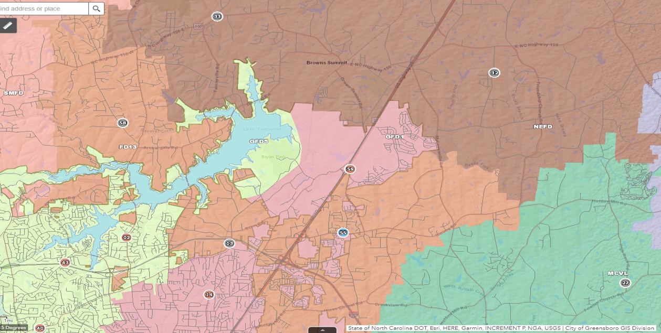

Emergency Response

Total Response
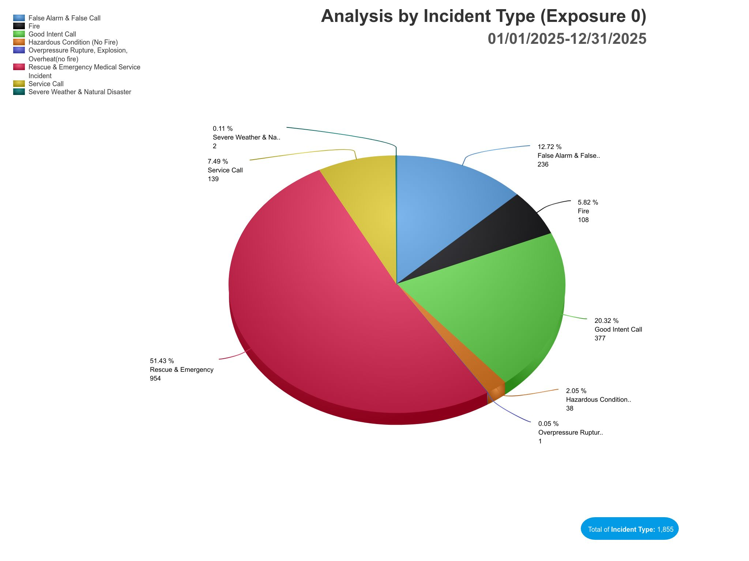

In 2025, FD13 responded to a total of 1,855 calls for service, an increase of 195 from 2024. Consistent with prior years, Rescue and Emergency Medical Assistance calls continue to comprise the majority of responses, accounting for 51.43% of total call volume.
Fire-related incidents—including structural fires, vehicle fires, and wood/grass fires—accounted for 5.82% of total calls. The remaining responses consist of service calls, hazardous conditions, and other non-fire emergencies, reflecting the diverse nature of the department’s operational workload.
These figures highlight the ongoing emphasis on EMS and rescue operations while demonstrating FD13’s comprehensive response capabilities across a wide spectrum of emergency scenarios.

Property Saved
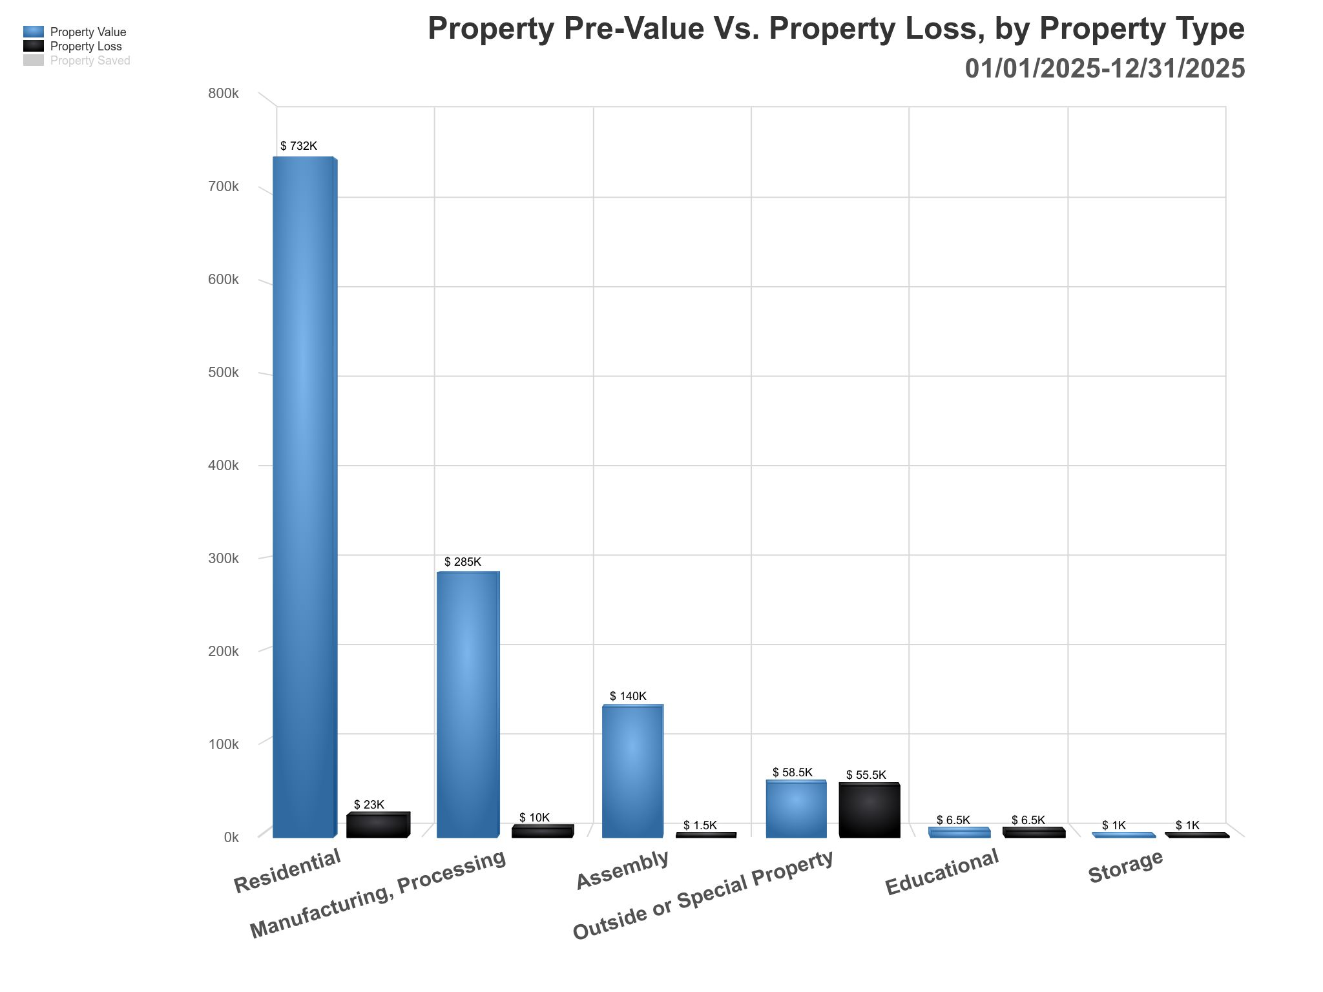

During the year, the total value of properties involved in structure fires was $1,223,000. Of that amount, the total documented loss was $97,500.
As a result, $1,125,500 in property value was preserved, representing 92.03% of the total property value at risk.
These figures reflect the department’s continued commitment to rapid response, effective fireground operations, and strategic incident management, all of which contribute significantly to property conservation and community resilience.

Station Response

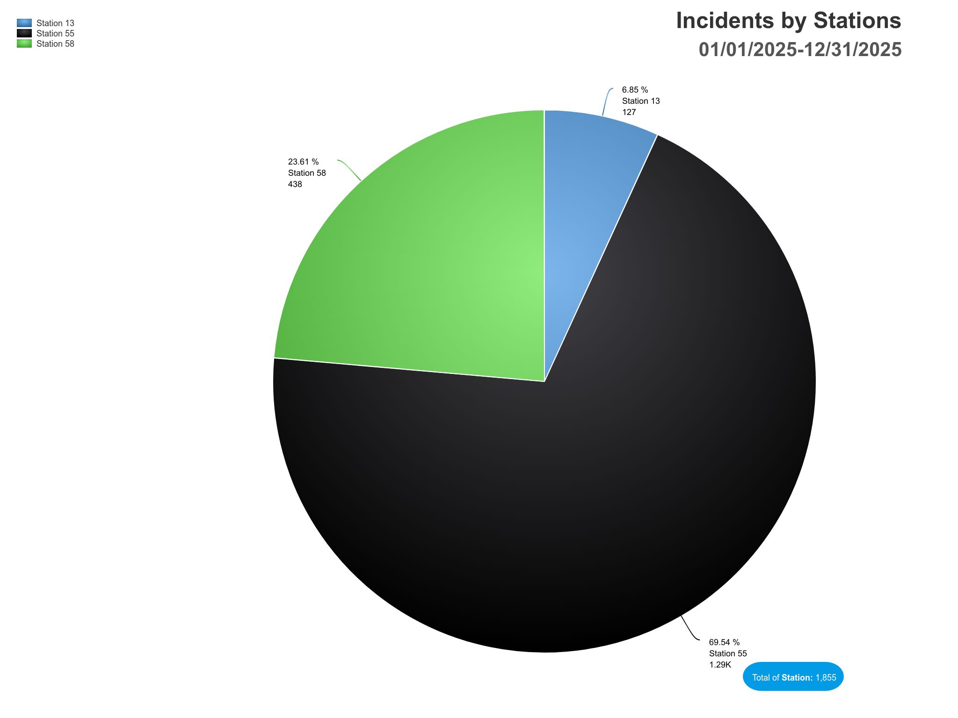

Apparatus Response
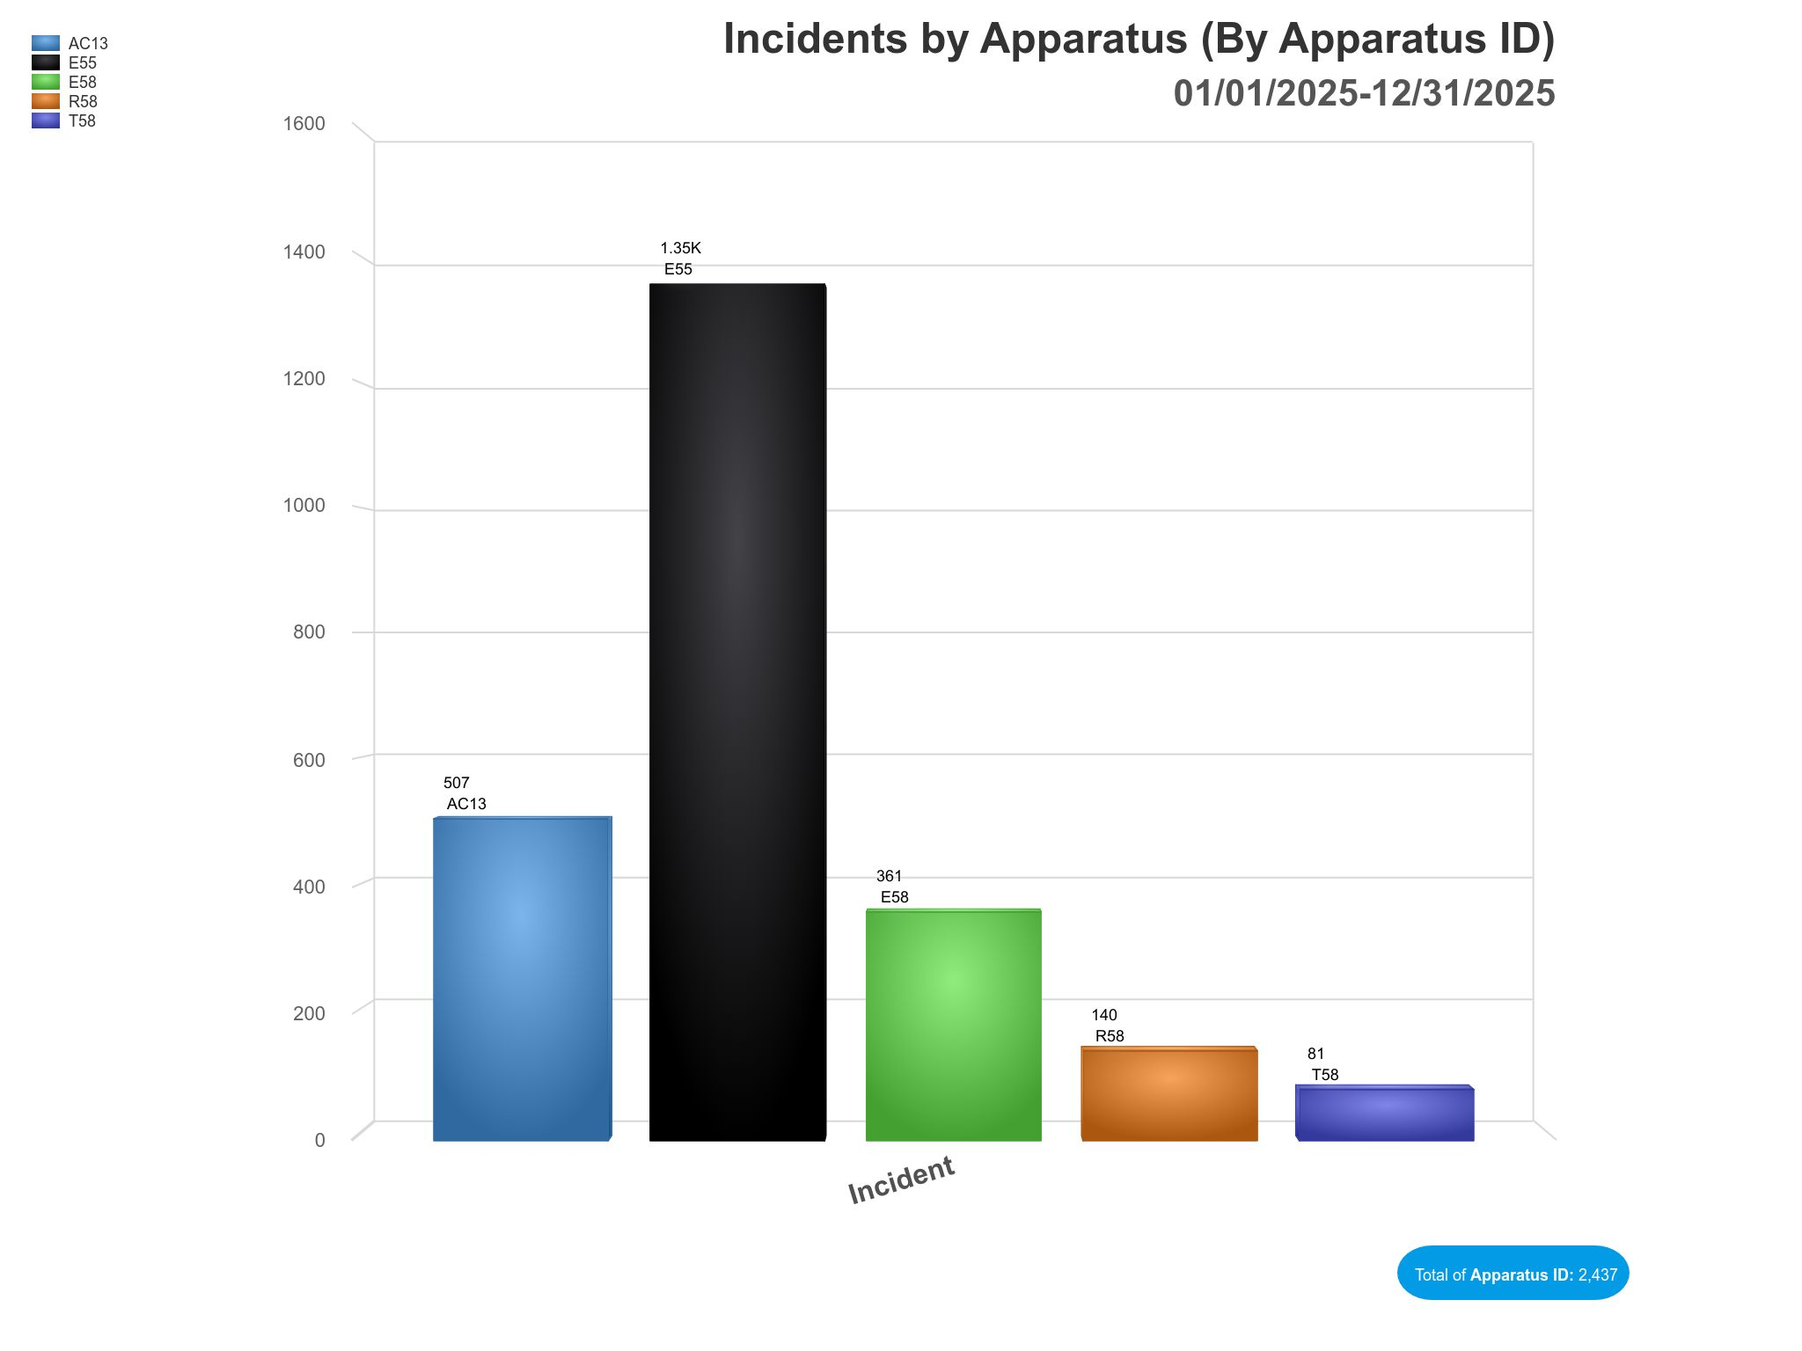

Station 55 and Engine 55 continue to account for the majority of calls for service within the district. In the past year, Engine 55 responded to 1,348 incidents, representing an increase of 176 calls compared to 2024.
This total reflects all responses, including first-due assignments as well as Automatic Aid and Mutual Aid deployments. The continued growth in call volume highlights both the increasing service demand within the district and FD13’s critical role in regional response operations.

Training

Training Totals
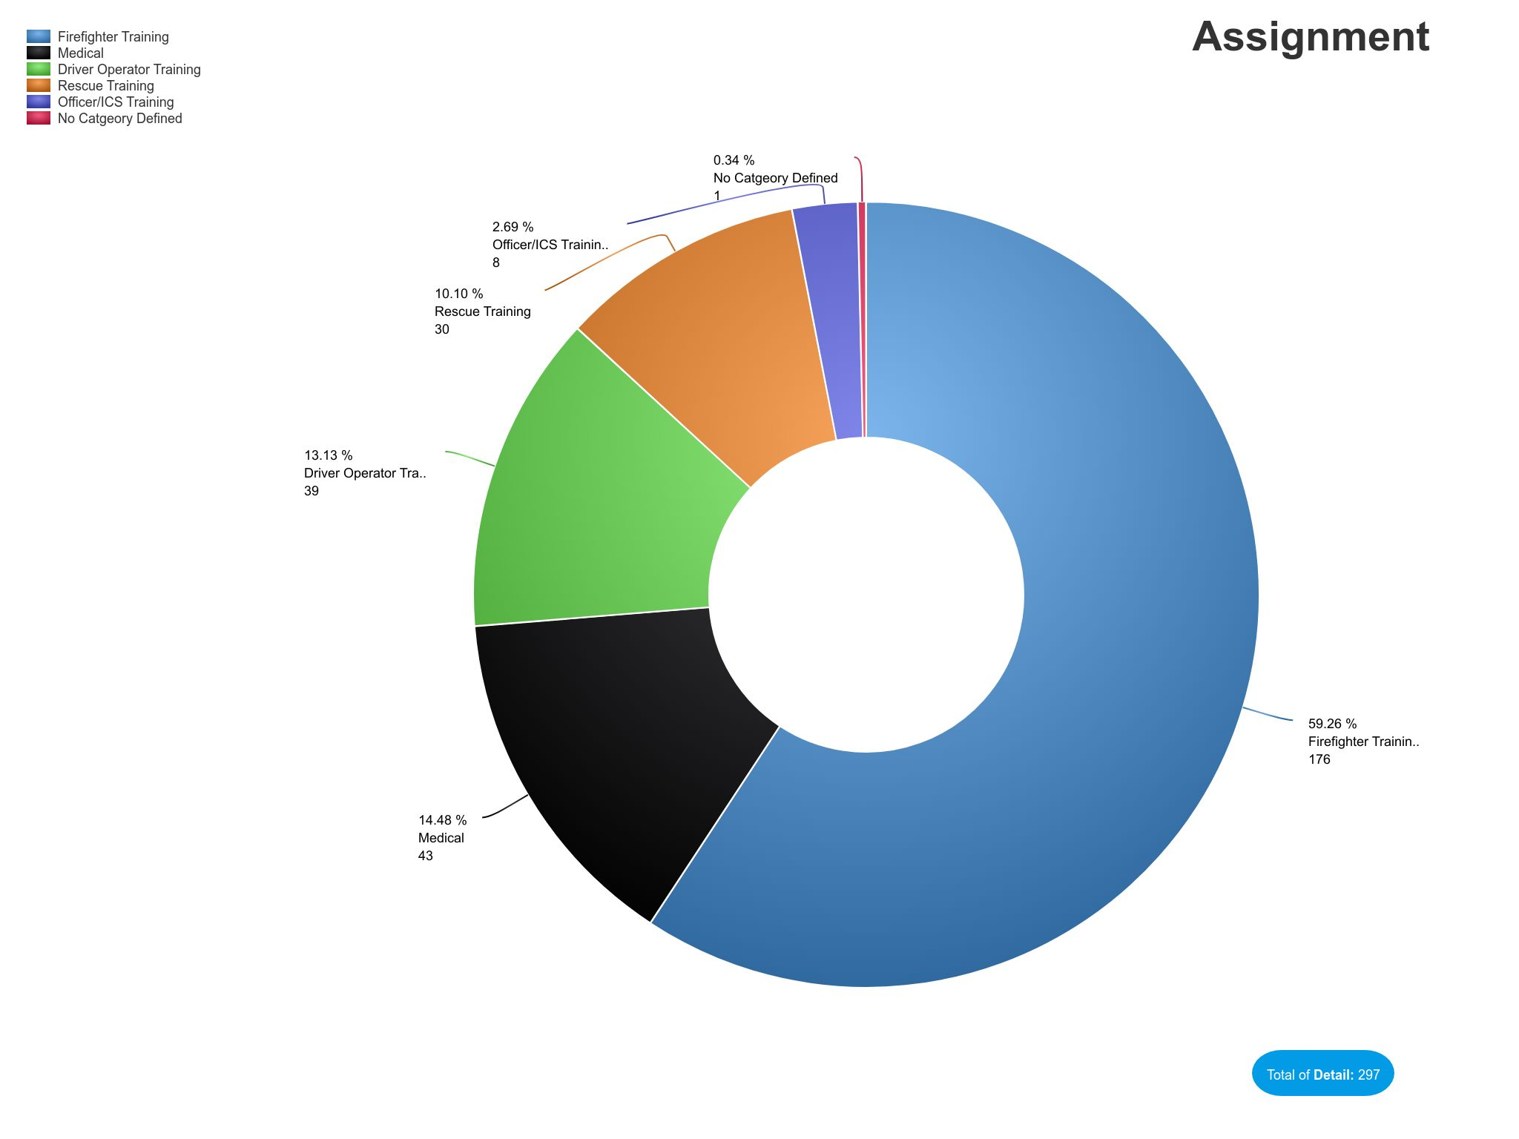
This year, our personnel conducted or participated in a total of 297 training events, resulting in 2,613 individual staff participations and 6,955 total staff training hours. The majority of this training is made possible by the facilities available on-site at Station 13. In 2025, we further enhanced our training capabilities with the addition of a Blue Door forcible entry training prop, representing a significant upgrade to our hands-on training resources.

Activities & Productivity

-Activity Total
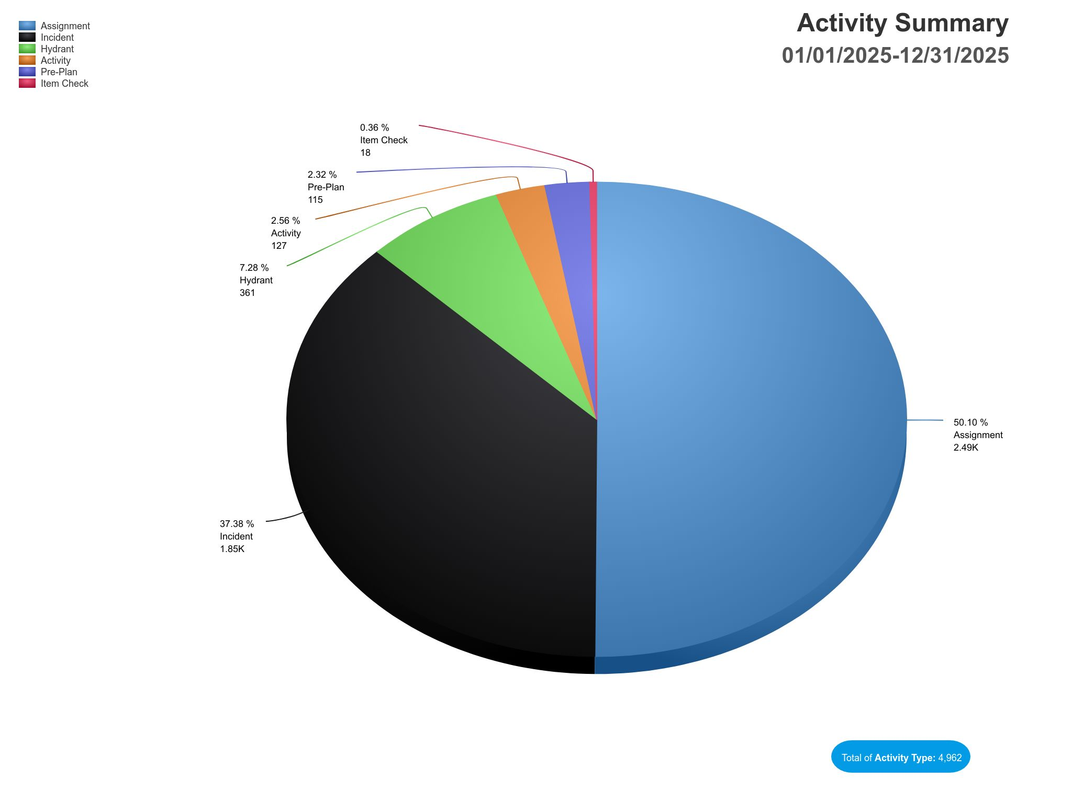
Emergency Response and Training continue to comprise the majority of daily activities, accounting for 87.48% of total personnel utilization. This figure does not include mealtimes, apparatus and station maintenance, or other periods of downtime. FD13 Administration recognizes the importance of maintaining an appropriate balance between productivity and recovery. Preserving this balance supports the overall health and well-being of our personnel while ensuring they remain fully prepared to respond when needed and perform at the high standard expected of our department.

Capital Projects

Station 55 Remodel

The remodel of Station 55 has officially commenced and is anticipated to be completed in early May. This project represents a significant upgrade in both technology and living accommodations, enhancing the overall functionality of the station and improving daily working conditions for the personnel assigned to Station 55.

Engine 55
This past year, we faced a significant challenge involving our apparatus. While our new Engine 55 remains under construction, the current Engine 55 was involved in a highway collision. Fortunately, no personnel were injured in the incident; however, the apparatus sustained substantial damage and required extensive repairs.
At this time, both the repaired Engine 55 and the newly constructed apparatus are scheduled for delivery in the second quarter of 2026.

New Engine 55

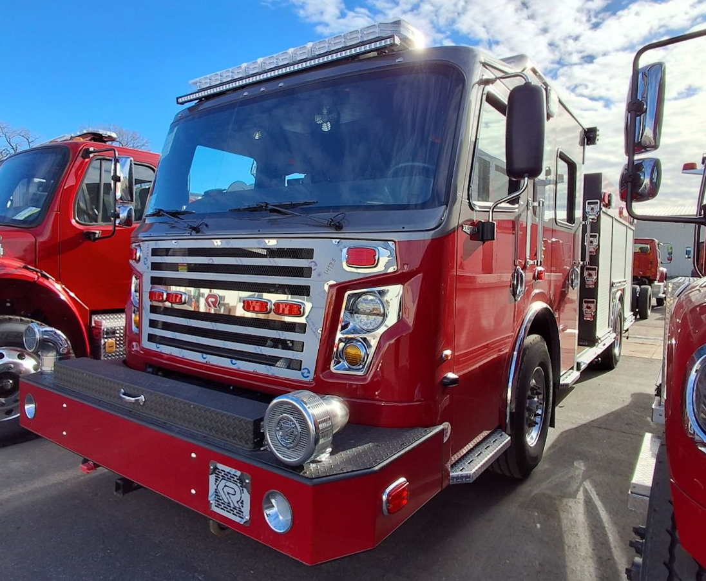

Repaired E55

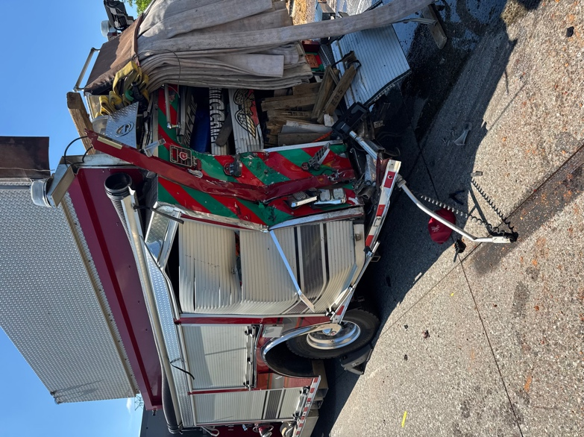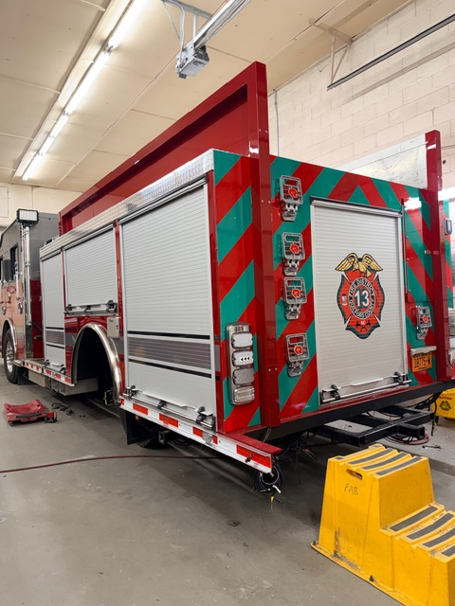

Closing Statement
FD13 continues to focus on operational readiness, professional development, infrastructure improvement, and responsible resource management. Through strategic planning, regional cooperation, and a commitment to personnel well-being, the department remains dedicated to protecting the citizens and critical infrastructure within the Rankin Fire District and surrounding areas.

From the Chief

As I reflect on the past year serving as fire chief, I would like to sincerely thank the membership. I am especially grateful to those of you who are out there every day, representing the department during some of our citizens’ darkest times. Your unwavering dedication, courage, and commitment make a genuine difference in our community. I also wish to express my gratitude to the Board of Directors for their support and guidance. This Board possesses a unique understanding of the importance of caring for our citizens by first supporting and investing in our employees. Their commitment to fostering a positive work environment, along with their dedication to providing high-quality equipment and resources, ensures that our team remains motivated, healthy, and prepared to meet the needs of the community. It is truly an honor to work alongside such outstanding individuals. The positive impact you have on the lives of others and the reputation you uphold for our department are deeply appreciated.

Sincerely,

C. Kevin King, Fire Chief

